**Pipe Crossing Guidelines**

“REMARK” shows in HelloSheets, not “Comments”

* Make as short as possible so the Alignment sheet isn’t cluttered
* Use “Comments”, “CROSSINGSIZE”, “Crossing Feature Type”/“Crossing Type”, “Material”, “Line Clearance”, and “DEPTHOFCROSSINGFEATURE” to populate REMARK
* **You will not be installing GForms for Foreign Line Crossings—only check the ones that have already been installed and make sure all information is filled in.**

**NOTE:** Line Clearance is in **Inches**, DEPTHOFCROSSINGFEATURE is in **Feet**, but both need to be in **Inches** in REMARK

**Fill out the following fields where information is given:**

Status Measure RouteID Crossing Feature Type

Crossing Type Crossing Location Position Line Clearance

Depth of Pipe Depth of Crossing Feature Comments

Remarks From Date Owner Crossing Size

Material Angle Clearance

* + **Crossing Feature Type and Crossing Type should match**
  + **Crossing Location and Position should match**
  + **Line Clearance is in INCHES**
  + **Depth of Pipe is in FEET**
  + **Depth of Crossing Feature is in FEET**
  + **From Date is the date of Installation of the Crossing. If the installation took more than one day, you can use the To Date**
  + **Crossing size is in INCHES**
  + **Clearance is in FEET**

**For all “Foreign” Lines, Drain Tile, Fiber Optic/Power/Telephone/Television Cable, Sewer Line, and Water Line:**

|  |  |  |  |  |  |
| --- | --- | --- | --- | --- | --- |
| Comments | CROSSINGSIZE | Crossing Feature Type | Material | Line Clearance | DEPTHOFCROSSINGFEATURE |
| Description: 12” Water Line encased in plastic sleeve; Source: Maintenance Record | 12 | Water Line | Plastic | 38 | 4.17 |

|  |
| --- |
| REMARK |
| 12” Plastic Water Line (50” Cover, 38” CLR) |

* If CROSSINGSIZE is <Null>, your REMARK should say

|  |
| --- |
| Unk Plastic Water Line (50” Cover, 38” CLR) |

* If Material is <Null>, your REMARK should say

|  |
| --- |
| 12” Water Line (50” Cover, 38” CLR) |

* If you have information for Cover, but not Clearance, your REMARK should say

|  |
| --- |
| 12” Plastic Water Line (50” Cover) |

* If Line Clearance and/or DEPTHOFCROSSINGFEATURE are <Null>, your REMARK should say

|  |
| --- |
| 12” Plastic Water Line |

* If everything is <Null> except Crossing Feature Type, your REMARK should say

|  |
| --- |
| Unk Water Line |

***If the Crossing is inside a casing, the Casing size and material should be in the Remark***

Example: 10” Water Line encased in 14” Concrete casing

|  |
| --- |
| 14” Concrete Water Line (50” Cover, 38” CLR) |

**For Roads, Driveways, State Highways, Interstate Highways, Creeks, Rivers, Trails, and Railroads:**

|  |  |  |  |  |  |
| --- | --- | --- | --- | --- | --- |
| Comments | CROSSINGSIZE | Crossing Feature Type | Material | Line Clearance | DEPTHOFCROSSINGFEATURE |
| Description: Barlow Rd.; Source: Original LS; Comments: Centerline calc. from Edge of Road.; Road Type: Road Centerline | <Null> | Road | <Null> | <Null> | <Null> |

|  |
| --- |
| REMARK |
| CL Barlow Rd |

* If the crossing is not located at the centerline of the River, Creek, etc., use “Edge of XX Creek” or “West Bank XX River”
* If you have the name of the Creek, River, Trail, or Railroad, include that information in the Remark.

|  |
| --- |
| REMARK |
| CL Burlington Northern RR |

|  |
| --- |
| REMARK |
| CL Cuyahoga River |

**For all Maintenance Records:**

* Fill in as much information from the MR as possible. If a field is not filled in on the sheet, it can be left blank in Arc

|  |  |
| --- | --- |
| **MR Field** | **Arc Field** |
| Depth of SPLP | Depth of Pipe (in Feet) |
| Foreign Line Depth | DEPTHOFCROSSINGFEATURE (in Feet) |
| Crossing Diameter | CROSSINGSIZE (in Inches) |
| Clearance | CLEARANCE (in Feet) / Line Clearance (in Inches) |
| Foreign Line Crossing Owner | Owner |
| Crossing Type + Crossing Product | Crossing Type / Crossing Feature Type |

**NOTE:** DEPTHOFCROSSINGFEATURE is what will go in your REMARK for **Cover, in** **INCHES**

* Once the Pipe Crossing has been installed in Arc, mark it on the Tracking spreadsheet as Completed.
* If no stationing is provided or the lat/long does not fall in the right location, the MR can be marked to be sent back to the author.
* When installing a Pipe Crossing, please enter the source and comments in the Comment field
  + **Example**: Per MR IC-123-15, installed 12” Plastic Water line below
* As you’re installing Pipe Crossings, please check the crossings on the rest of the line to ensure all of the existing records follow this format.
* The GIS File # naming format in the Tracking spreadsheet is:

**Line number**_**beginning station** (seven digits)_**F** (for Foreign Line Crossing)

**Example:** 12345_0123456_F

* + If your stationing is less than 7 digits long, use zeroes before your station number

**Example:** Station 12+34 = 0001234

**SAMPLE MAINTENANCE RECORD:**

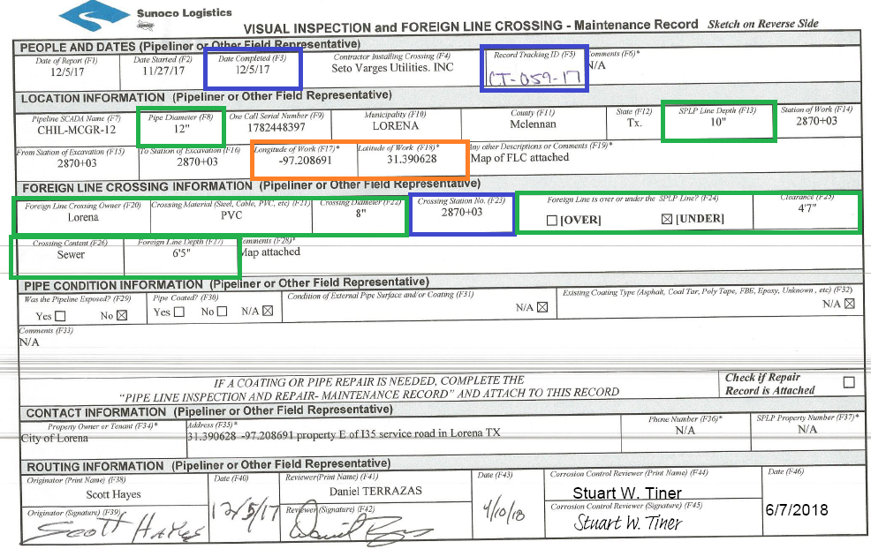

**Boxes in Blue:** Information used in the Tracking spreadsheet

**Boxes in Orange**: The lat/long you will use to find your crossing

**Boxes in Green**: Information you will enter into Arc

**Boxes in Yellow**: Information you can fill out in Comments in Arc